Money Management
1-2-1 Advocacy Referral Form

A Money Management Advocate can help you with speaking up and getting the right support with your money problems.
Date of Referral:

 | Details of person being referred
Learning disability or autism |  | Does the person being referred have:  A learning disability: Yes ☐ No ☐  Autism: Yes ☐ No ☐
Name of person being referred
Who is filling in this form?  (please tick) |  | ☐ Myself ☐ Myself with support ☐ Lewisham Speaking Up  ☐Other (please say who):
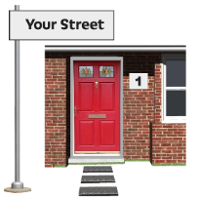  Address of person who needs advocacy |  | Postcode:

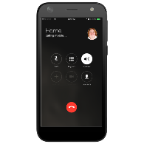
Telephone number/s
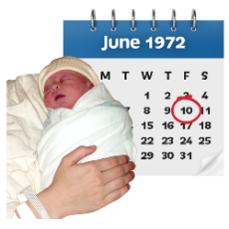
Date of birth
Your disability

Any health issues?
Name of Social Worker and contact details
(if any)

Name of housing provider and contact person
(if known)

Participant Monitoring Information
To help us with our monitoring and reporting please tell us the following information. This information will be kept private at all times.

1. Disability
Do you consider yourself to be disabled? | Yes ☐ | No ☐
If you want to, please say what disability

2. Ethnicity: Please tick or say if you tick ‘other’
Arab | Arab | ☐
Asian/Asian British | Bangladeshi | ☐
 | Chinese | ☐
 | Indian | ☐
 | Pakistani | ☐
 | Any other Asian background | ☐
Black/Black British | African | ☐
 | Caribbean | ☐
 | Any other Black background | ☐
Mixed Ethnic | Any mixed background | ☐
White | British | ☐
 | Irish | ☐
 | Gypsy or Irish Traveller or Roma | ☐
 | Any other White background | ☐
Other | Any other ethnic background | ☐

3. Religion or belief: please tick or say if you tick ‘other religion’
No religion | ☐
Buddhist | ☐
Christian | ☐
Hindu | ☐
Jewish | ☐
Muslim | ☐
Sikh | ☐
Other religion | ☐

4. Sexual orientation
Bisexual | ☐
Gay | ☐
Heterosexual | ☐
Lesbian | ☐
Prefer not to say | ☐

5. Gender
Female | ☐
Male | ☐
Transgender | ☐
Gender Neutral or Fluid | ☐
Prefer not to say | ☐

Referrer:
A referral can be made by anybody who knows the person i.e. Social Worker, Key Worker, Support Worker, Parent, Carer, Friend, Neighbour.

Name
Job title or relationship
Organisation
(if applicable)
Address

Telephone

Email

Risks
(please state any risks we should be aware of when supporting with person)

Does the person receive a support service from London Borough of Lewisham?
(i.e. supported living, outreach service)
Person’s communication (how does the person communicate?)
How did you hear about our service?
Reason(s) for referral | ☐ Benefits: Universal Credit ☐ Benefits: PIP /DLA  ☐ Benefits: Housing/Rent debt ☐ Benefits: Carers Allowance  ☐ Benefits: ESA ☐ Council Tax Debt  ☐ Benefits: Incapacity Benefit ☐ Phone debt  ☐ Freedom Passes ☐ Utility Bill debt  ☐ Bank Account problems ☐ Other

Please give more information about the reason for referral
What changes need to happen
- What do you want to happen?
- What change are you looking for?

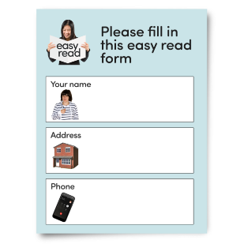
More information:
(i.e. person’s day activities, living arrangements – with family, supported living, independently)

Is person aware of the referral?  (If no, please say why not) | Yes ☐ No ☐

Person’s
Signature

Referrer Signature

Date

Please return this form to us:

By post:  1-2-1 Advocacy  Lewisham Speaking Up  The Leemore Centre  29-39 Clarendon Rise  London SE13 5ES |  | Email:  referrals@lsup.org.uk

